1.) bubble sort (linked list).cpp (output)

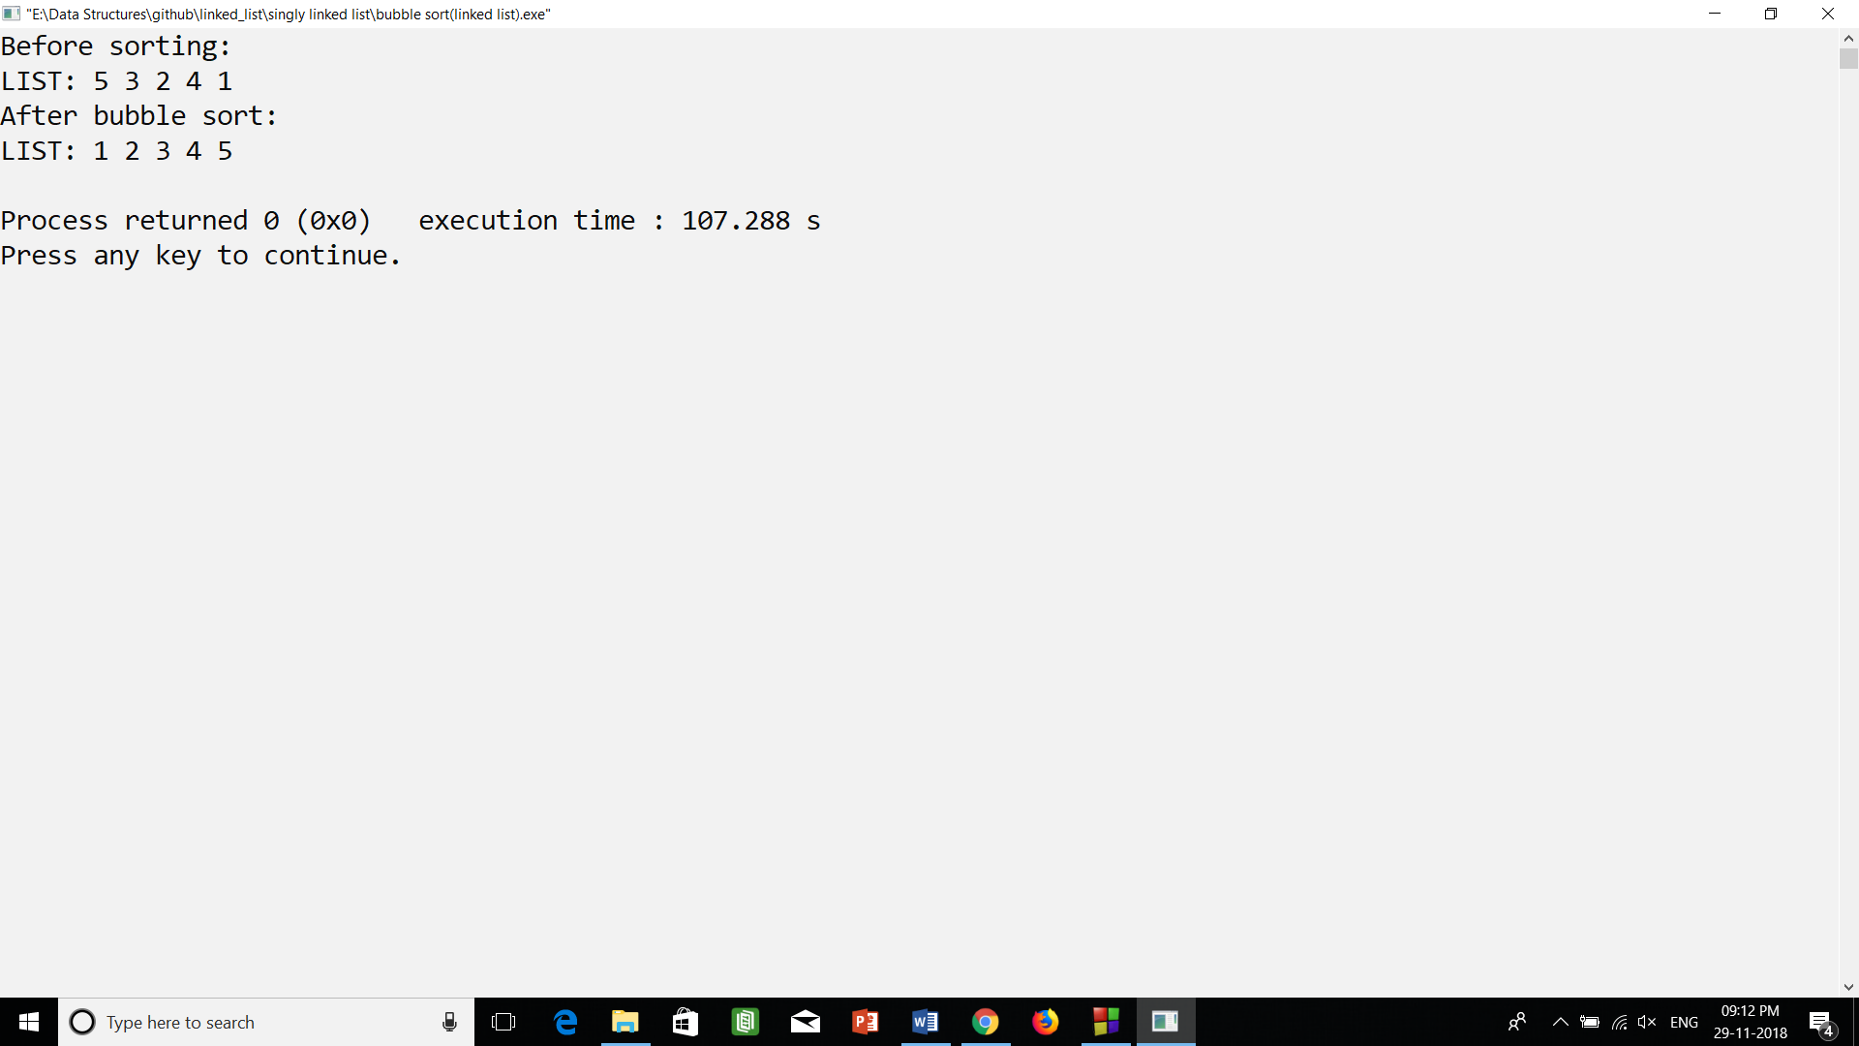

2.) linked list (structure in class).cpp (output)

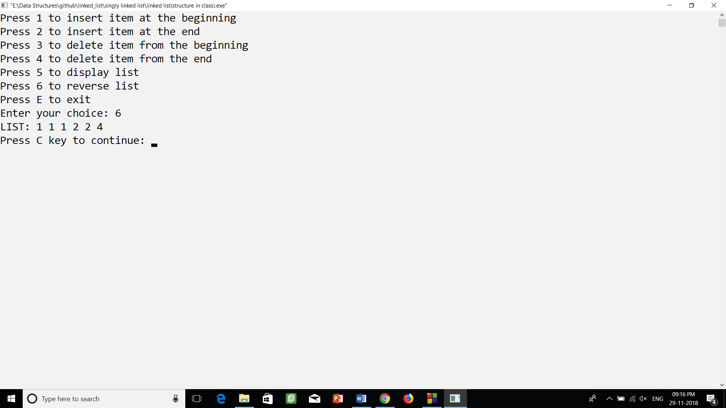

3.) linked list (using class).cpp (output)

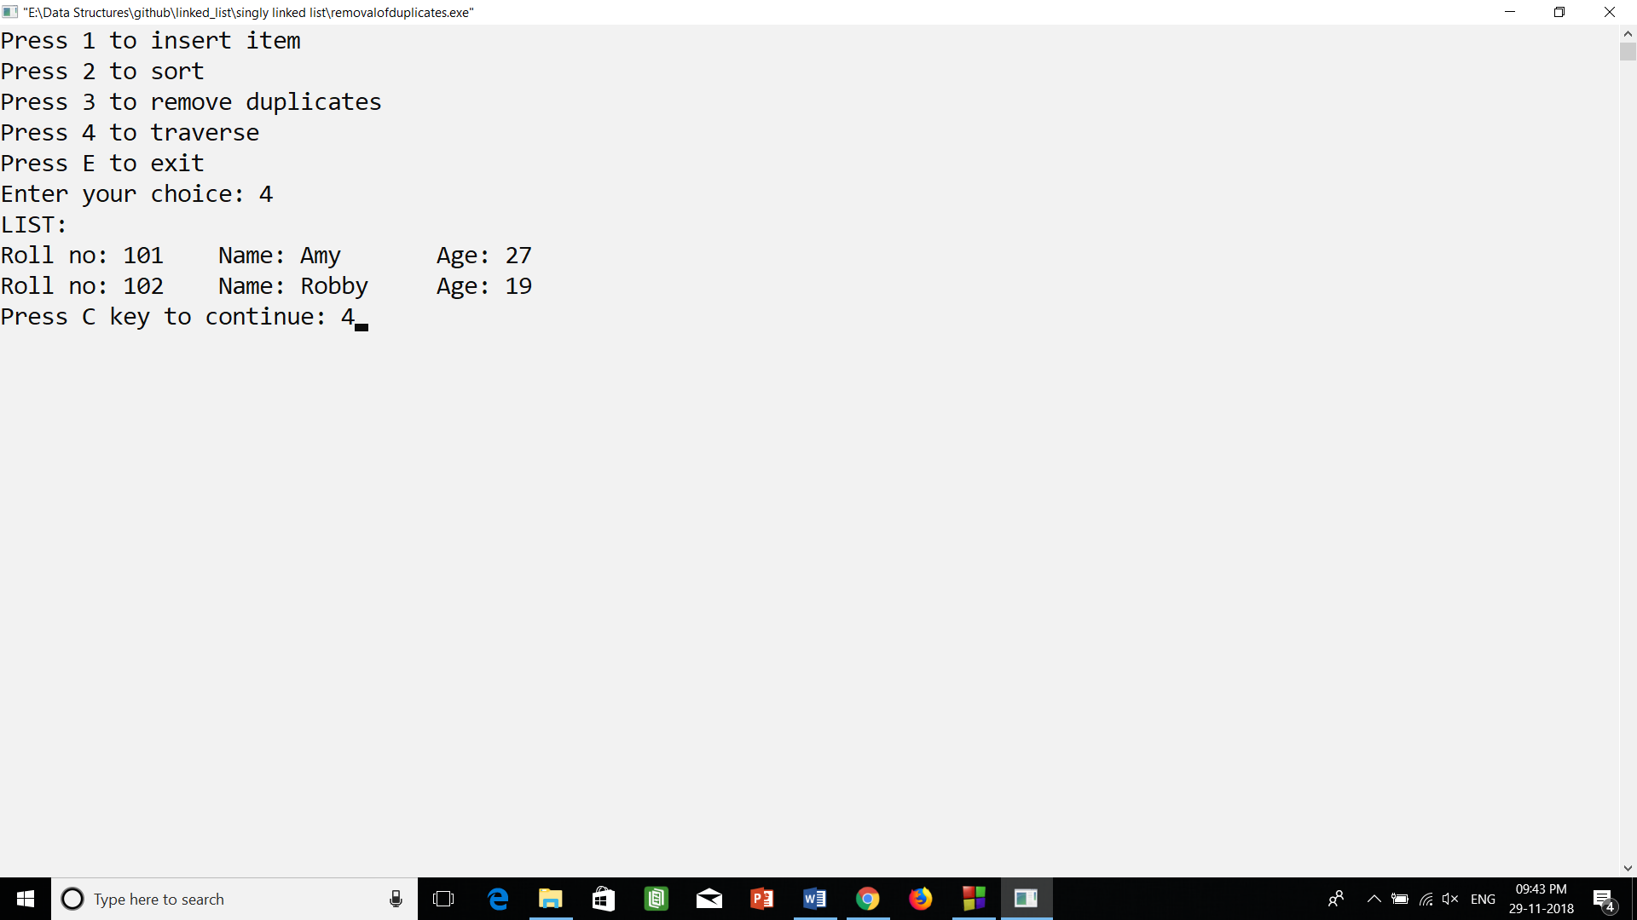

4.) linked list (using struct and class).cpp (output)



5.) linked list.cpp (output)

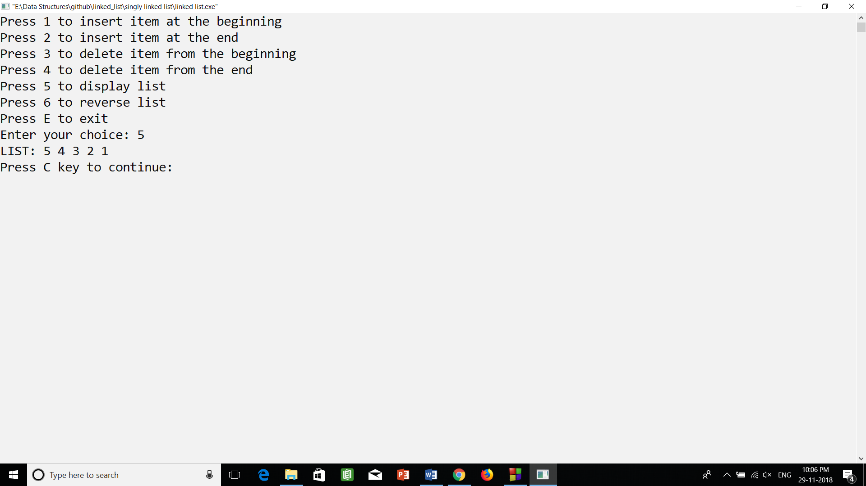

6.) removalofduplicates.cpp (output)

